*Snapshot Sleuths*

*Educator Handout*

**Overview**

Snapshot Wisconsin is used to identify millions of photos of wildlife. However, sometimes these photos can be difficult to identify. Luckily, there are features of a species (i.e.: behavior, discrete markings, habitat, etc.) that can help tell us what’s in the picture. In this activity, you will help participants identify pictures of wildlife that are difficult to classify from a species bank with information on specific life history traits.

**Procedure**

1. Set up 10 stations with the 10 provided animal photos and its corresponding species bank, set side-by-side.
2. Split up participants into groups (10 maximum). Each group will start at a different station.
3. Give participants 2-3 minutes per station to look at the species bank and determine what is in the photo (groups should keep answers to themselves as best they can).
4. Have groups rotate after the 2-3 minutes. Rotate through all 10 stations.
5. After all groups have gone through each station, have all participants reconvene and discuss each picture together, sharing what they think the picture is and why they think that.

**Talking Points/Key Concepts**

* There are several ways to identify a species.
* Sometimes species can appear similar but have diagnostic traits that differentiate them.
* Habitat and behavior can also tell us a lot about which species we’re looking at.
* What other Wisconsin species can participants think of that have unique identifying traits?

*Snapshot Wisconsin created this activity in collaboration with Drake Stallworth, 2023 Snapshot Wisconsin and Natural Resources Foundation Intern. Feedback is always welcomed! Any questions or comments? Contact us at DNRSnapshotWisconsin@Wisconsin.gov.*



**Note:** Stations can be placed in any order, regardless of the Species Bank Number. Make sure to place the pictures with the corresponding species bank.

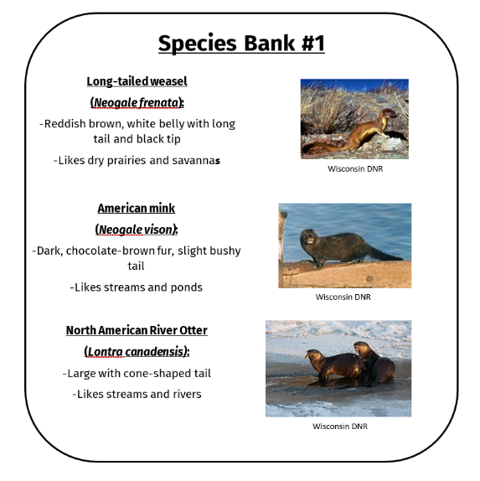**Setup Example**

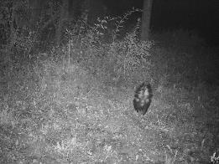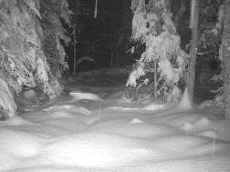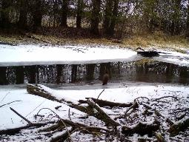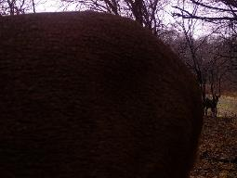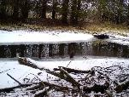

**Snowshoe Hare (Species Bank #4)**

**Striped Skunk (Species Bank #3)**

**White-tailed Deer (Species Bank #2)**

**American Mink (Species Bank #1)**

*Snapshot Wisconsin created this activity in collaboration with Drake Stallworth, 2023 Snapshot Wisconsin and Natural Resources Foundation Intern. Feedback is always welcomed! Any questions or comments? Contact us at DNRSnapshotWisconsin@Wisconsin.gov.*

**Answer Key:**

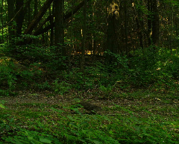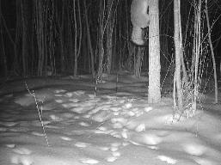

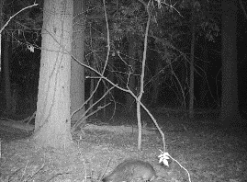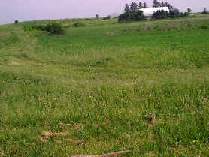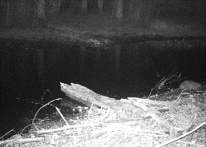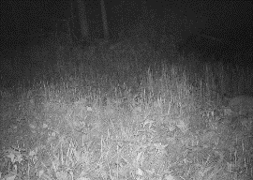

**American Badger (Species Bank #10)**

**Ring-necked Pheasant (Species Bank #9)**

**Bobcat (Species Bank #8)**

**Muskrat (Species Bank #7)**

**Woodchuck (Species Bank #6)**

**Gray Fox (Species Bank #5)**

**Species Bank #1**

**Long-tailed weasel**

**(*Neogale frenata*):**

-Reddish brown, white belly with long tail and black tip

-Commonly found in dry prairies and savannas

**American mink**

**(*Neogale vison)*:**

-Dark, chocolate-brown fur, slight bushy tail

-Commonly found in streams and ponds

**North American River Otter**

**(*Lontra canadensis)*:**

-Large with cone-shaped tail

-Commonly found in

streams and rivers

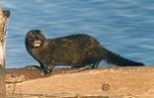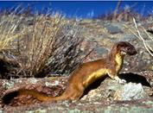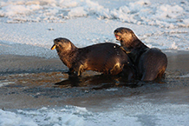

Wisconsin DNR

Wisconsin DNR

Wisconsin DNR

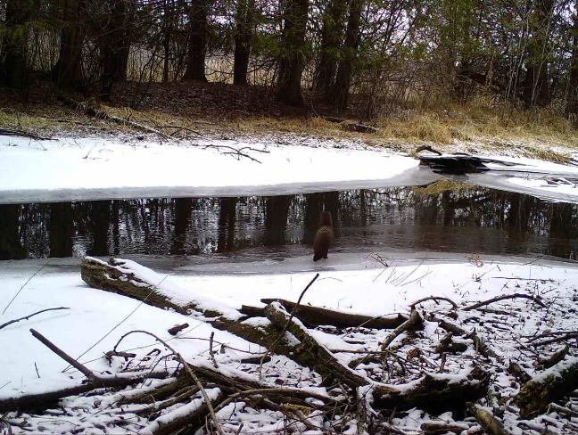

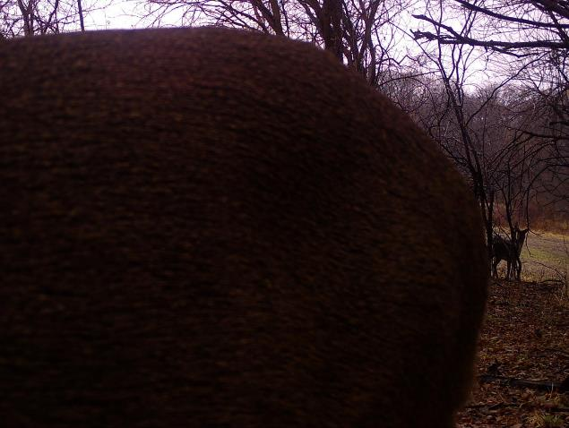

**Species Bank #2**

**White-tailed Deer**

**(*Odocoileus virginianus*):**

-Large, long-legged with short, tan hair

-Commonly found in groups

**American Black Bear**

**(*Ursus americanus)*:**

-Dark, black fur

-Large bodied but short-legged and relatively low to the ground

**Elk**

**(*Cervus canadensis)*:**

**-**Longer coat, larger body size than deer

-Dark brown head and distinct white rump

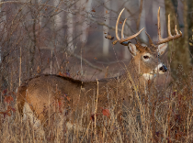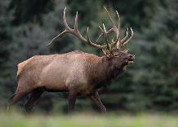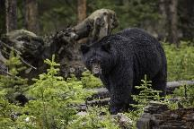

Wisconsin DNR

Wisconsin DNR

Wisconsin DNR

**Species Bank #3**

**Eastern Gray Squirrel**

**(*Sciurus carolinensis*):**

-Slender body with gray fur and long, bushy tail

-Primarily active during the day

**Striped Skunk**

**(*Mephitis mephitis*):**

-Black and white fur, stout body, wide bushy tail

-Nocturnal, walks with tail upright

**Raccoon**

**(*Procyon lotor*):**

-Gray stout body with ringed tail

-Nocturnal, walks with tail down

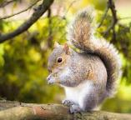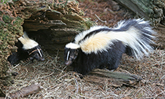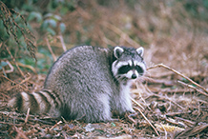

Wisconsin DNR

Wisconsin DNR

Wisconsin DNR

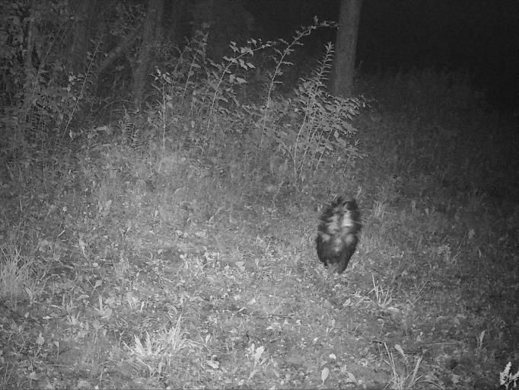

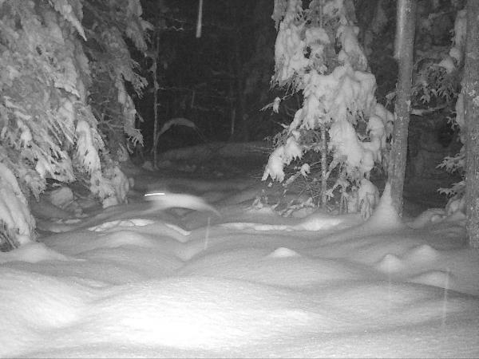

**Species Bank #4**

**Short-tailed Weasel**

**(*Mustela erminea*):**

-Long slender body with longer tail with black tip

-Coat turns white in winter

**Eastern Cottontail**

**(*Sylvilagus floridanus*):**

**-**Very short tail with long ears and long hind legs

-Stays gray-brown all year

**Snowshoe Hare**

**(*Lepus americanus*):**

-Very short tail with long ears and long hind legs

-Coat turns white in winter

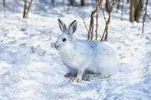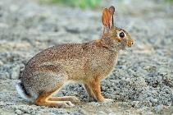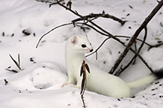

Wisconsin DNR

Wisconsin DNR

Wisconsin DNR

**Species Bank #5**

**Eastern Gray Squirrel**

**(*Sciurus carolinensis*):**

-Gray fur with all-gray bushy tail

-Small body size, climbs trees

**Red Fox**

**(*Vulpes vulpes*):**

-Red fur, dark legs, long bushy tail with white tip

-Stays on the ground

**Gray Fox**

**(*Urocyon cinereoargenteus*):**

-Gray fur, long bushy tail with black tip

-Often climbs trees

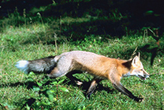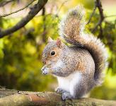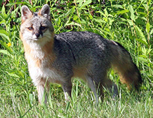

Wisconsin DNR

Wisconsin DNR

Wisconsin DNR

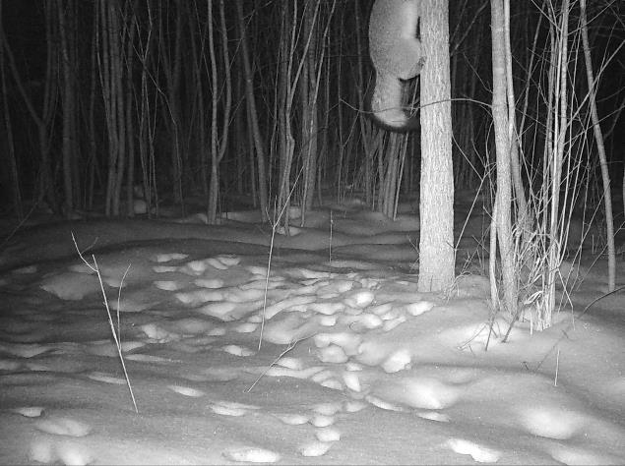

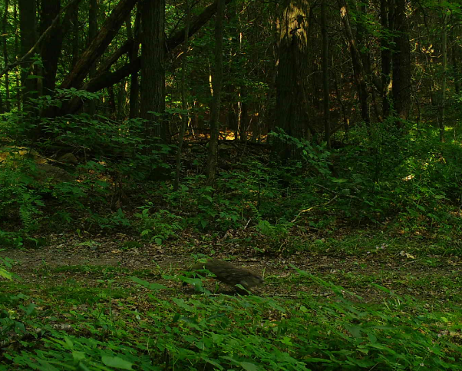

**Species Bank #6**

**Muskrat**

**(*Ondatra zibethicus*):**

-Brown fur with long, hairless tail

-Commonly found near streams and ponds

**Woodchuck**

**(*Marmota monax*):**

**-**Grayish-brown fur, stocky body, short furry tail

-Prefers terrestrial (land) habitats

**Eastern Gray Squirrel**

**(*Sciurus carolinensis*):**

-Medium-sized with long bushy tail and gray fur

-Prefers habitat with trees

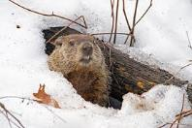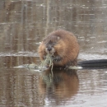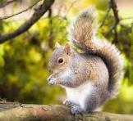

Wisconsin DNR

Wisconsin DNR

USFWS

**Species Bank #7**

**North American Beaver**

**(*Castor canadensis*):**

-Large with brown fur and flat, paddle-shaped leathery tail

-Commonly found near rivers, streams, ponds

**Virginia Opossum**

**(*Didelphis virginiana*):**

-White face with long, hairless tail

-Prefers habitat with trees

**Muskrat**

**(*Ondatra zibethicus*):**

-Brown fur with long, hairless tail

- Commonly found near streams, rivers, ponds

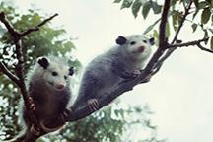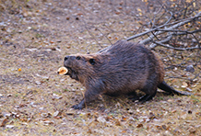

Wisconsin DNR

Wisconsin DNR

Wisconsin DNR

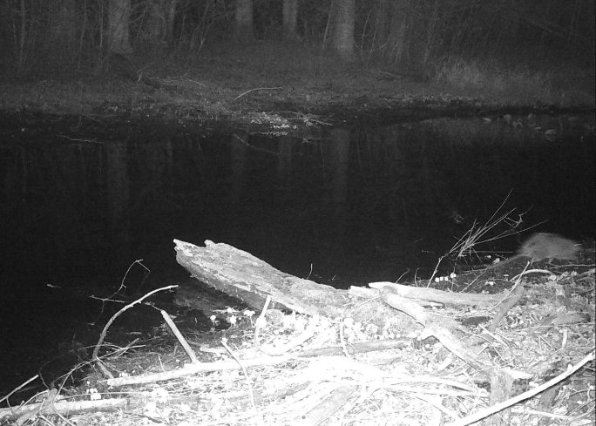

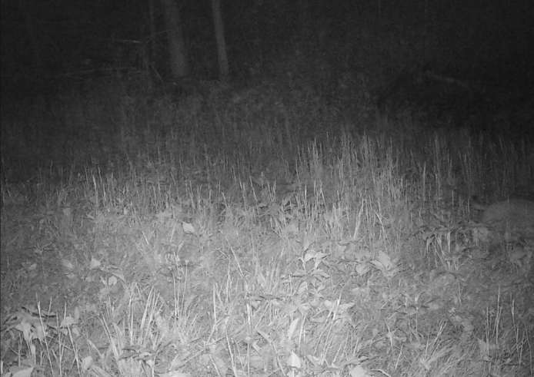

**Species Bank #8**

**Bobcat**

**(*Lynx rufus*):**

-Larger than house cat, coat sometimes has spots

-Short tail with black tip

**Coyote**

**(*Canis latrans*):**

-Approximately the size of a medium-sized dog, such as a border collie

-Medium length tail

**Eastern Cottontail**

**(*Sylvilagus floridanus)*:**

-Very short, white fluffy tail

-Hops around

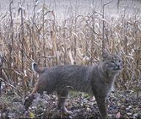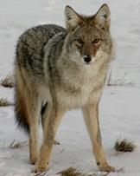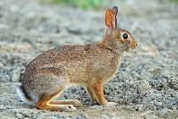

Wisconsin DNR

Wisconsin DNR

Wisconsin DNR

**Species Bank #9**

**Wild Turkey**

**(*Meleagris gallopavo*):**

-Flat, rectangular shaped tail (when folded)

-Dark body plumage with pale, featherless head

**Greater Prairie Chicken**

**(*Tympanuchus cupido*):**

-Plumage is striped with short, roundish tail

-Male has long feathers on side of head above yellow inflatable sacs

**Ring-necked Pheasant**

**(*Phasianus colchicus*);**

-Tan body plumage and long, pointy, striped tail

-Male has green head with red featherless parts

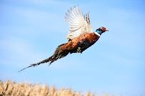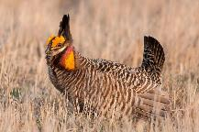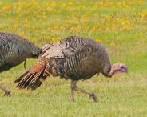

Wisconsin DNR

Wisconsin DNR

Wisconsin DNR

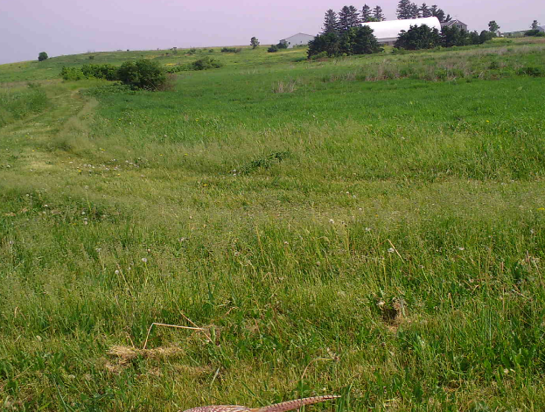

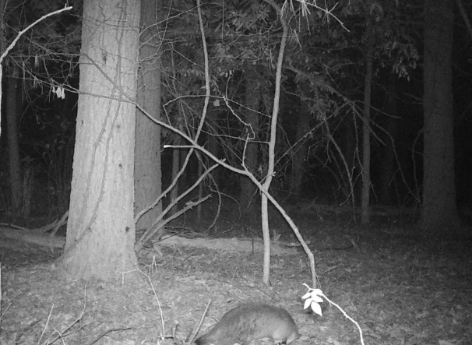

**Species Bank #10**

**Fisher**

**(*Pekania pennanti*):**

-Dark brown fur with long bushy tail

-Long, slender brown body

**American Badger**

**(*Taxidea taxus*):**

-Gray/brown fur with dark legs and short tail

-Flat, stout body with black and white head

**Red Fox**

**(*Vulpes vulpes*):**

-Red fur with dark long legs

-Slender body, pointy ears, long bushy tail

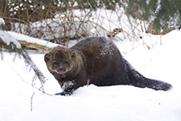

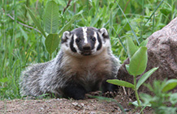

Wisconsin DNR

Wisconsin DNR

Wisconsin DNR

Long-tailed weasel:

-likes dry prairies

-lighter brown with white belly, long bushy tail

Mink:

-likes ponds and creeks

-slick, dark brown

River Otter:

-likes rivers and creeks

-large with cone-shaped tail and thin coat

**Species Bank #1:**

Long-tailed weasel:

-likes dry prairies

-lighter brown with white belly, long bushy tail

Mink:

-likes ponds and creeks

-slick, dark brown

River Otter:

-likes rivers and creeks

-large with cone-shaped tail and thin coat

**Species Bank:**

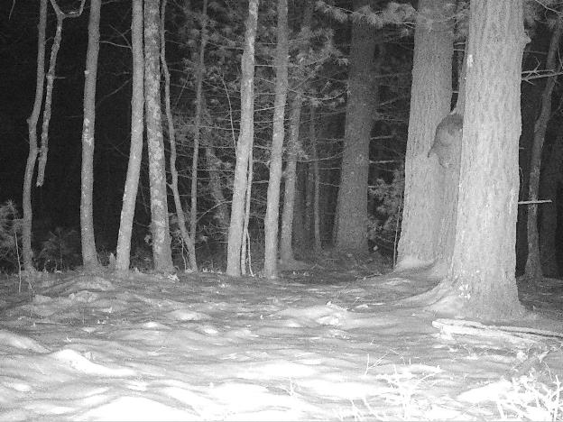

Long-tailed weasel:

-likes dry prairies

-lighter brown with white belly, long bushy tail

Mink:

-likes ponds and creeks

-slick, dark brown

River Otter:

-likes rivers and creeks

-large with cone-shaped tail and thin coat

**Species Bank:**

Long-tailed weasel:

-likes dry prairies

-lighter brown with white belly, long bushy tail

Mink:

-likes ponds and creeks

-slick, dark brown

River Otter:

-likes rivers and creeks

-large with cone-shaped tail and thin coat

**Species Bank:**

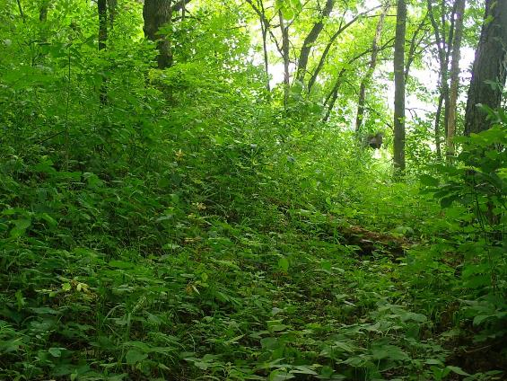

Long-tailed weasel:

-likes dry prairies

-lighter brown with white belly, long bushy tail

Mink:

-likes ponds and creeks

-slick, dark brown

River Otter:

-likes rivers and creeks

-large with cone-shaped tail and thin coat

**Species Bank:**

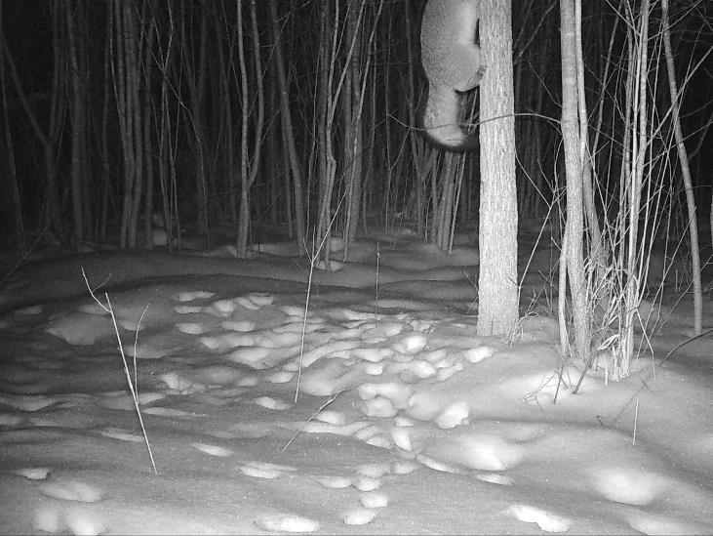

Long-tailed weasel:

-likes dry prairies

-lighter brown with white belly, long bushy tail

Mink:

-likes ponds and creeks

-slick, dark brown

River Otter:

-likes rivers and creeks

-large with cone-shaped tail and thin coat

**Species Bank:**

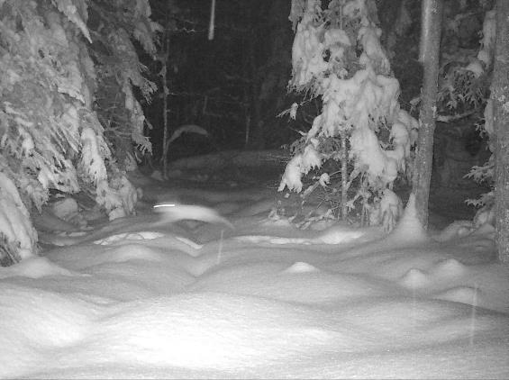

Long-tailed weasel:

-likes dry prairies

-lighter brown with white belly, long bushy tail

Mink:

-likes ponds and creeks

-slick, dark brown

River Otter:

-likes rivers and creeks

-large with cone-shaped tail and thin coat

**Species Bank:**

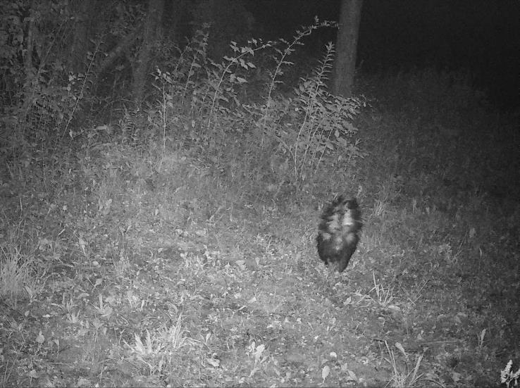

Long-tailed weasel:

-likes dry prairies

-lighter brown with white belly, long bushy tail

Mink:

-likes ponds and creeks

-slick, dark brown

River Otter:

-likes rivers and creeks

-large with cone-shaped tail and thin coat

**Species Bank:**

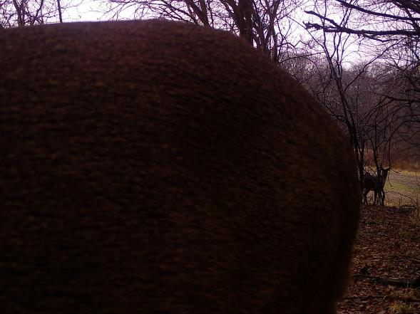

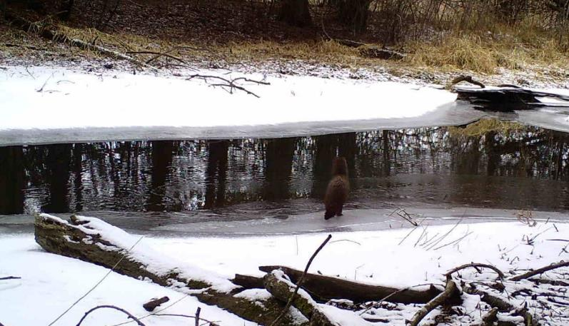

Long-tailed weasel:

-likes dry prairies

-lighter brown with white belly, long bushy tail

Mink:

-likes ponds and creeks

-slick, dark brown

River Otter:

-likes rivers and creeks

-large with cone-shaped tail and thin coat

**Species Bank:**

Long-tailed weasel:

-likes dry prairies

-lighter brown with white belly, long bushy tail

Mink:

-likes ponds and creeks

-slick, dark brown

River Otter:

-likes rivers and creeks

-large with cone-shaped tail and thin coat

**Species Bank:**

