LOD (MDL) Study Instructions [Version 6/30/23]
See the spreadsheet for additional notes and instructions

Initial LOD: You will need to do a new LOD if you start doing a new method, the method is altered in a way that affects sensitivity, you only run a certain test a couple of times per year, or if your ongoing LOD doesn’t pass (see next section). To do the initial LOD:
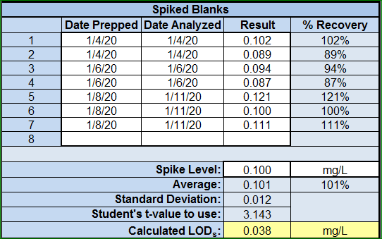
- Prepare 2 or 3 spiked blanks on at least 3 different days so that you have at least seven spiked blanks.
  - For example, you can prepare two 0.1 mg/L total phosphorus solutions on Monday and run the samples on Monday. On Wednesday, you can prepare two 0.1 mg/L total phosphorus solutions and run then on Wednesday. On Friday you can prepare three 0.1 mg/L total phosphorus solutions and run then on Friday. You don’t have to prepare and analyze them the same day, but you do still need at least 3 days of prep and 3 days of analysis.
  - If you happen to have blank spikes at 0.1 mg/L, say from a low-level standard check, you can use that data, but you need to use the most recent data.
  - Enter this data in the spreadsheet. Use the tab labeled “Initial LOD.” Enter all dates, results, and the spike concentration in the section labeled, “Spiked Blanks.”
- If any of the spiked blanks give a negative result, you need to start the initial LOD again but at a higher concentration.
- The LOD_{s} is calculated by the spreadsheet (standard deviation x student’s t-value).
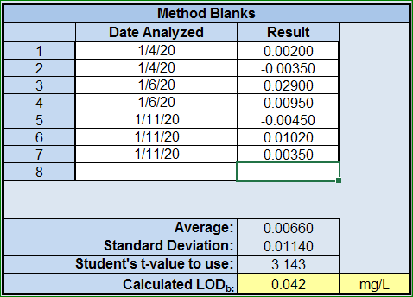
- Compile the most recent method blanks you’ve run to calculate the LOD_{b}.
  - If this is a new method or rarely used method and you don’t have at least 7 method blanks, you will need to analyze a method blank with each of the spiked blanks you ran in step 1.
  - Enter this data in the spreadsheet in the section labeled, “Method Blanks.”
  - Be sure to enter “-” with any negative values that were measured.
  - The LOD_{b} is calculated by the spreadsheet (average + [standard deviation x student’s t-value]).
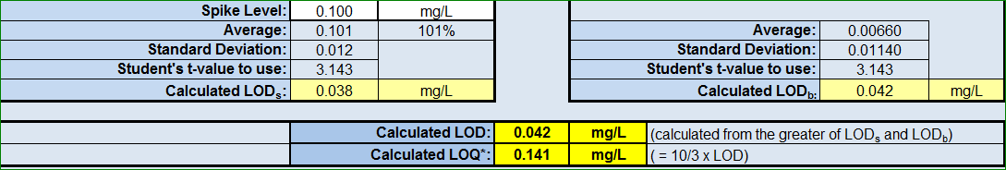
- The LOD will be the higher of the LOD_{s} or LOD_{b} (the spreadsheet will automatically calculate it).

LOD (MDL) Study Instructions (Continued)
Ongoing LOD and Verification: Once you have all of your initial LOD studies done, you will need to start collecting data for the ongoing studies. Only the ongoing LOD, instead of the initial LOD, will need to be done every year except for the reasons stated above for the initial LOD. To do the ongoing LOD and verification:
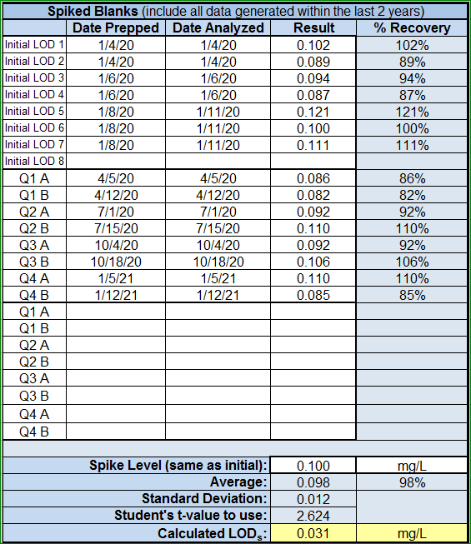
- Each quarter, prepare and run at least 2 spiked blanks using the same concentration as that used for initial LOD. These must be run in different batches each quarter. By the end of twelve months, you will have 8 spiked blanks.
  - If a method is rarely run, you only need to run the 2 spiked blanks in quarters that you run actual samples (PT samples aren’t considered actual samples).
- If more than 5% of the spiked blanks are negative, the initial LOD must be redone at a higher concentration (the spreadsheet will alert you).
- Calculate the LOD_{s} with all data from the last two years (no more, no less), but only data with the same spiking level. This may include the 7 or 8 spiked blanks from the initial LOD if it was done within the last 2 years.
- Enter this data on the “Ongoing LOD” tab of the spreadsheet. Not all of the lines in the Spiked Blanks section need to be filled (once the initial LOD is more than 2 years old, only 16 spaces will used).
- Compile all method blanks. Ideally, use all method blanks from the last 2 years.
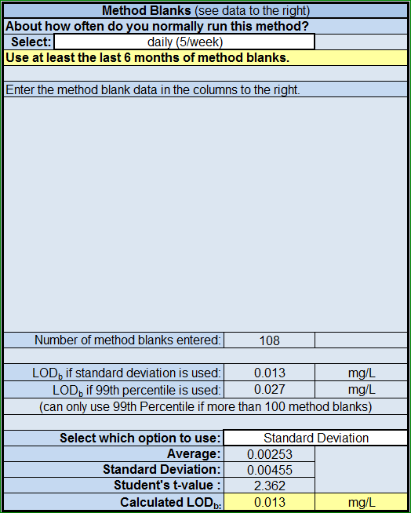
  - If more than 100 method blanks have been run in the last 2 years, you have the option to use either the 99th percentile calculation or the standard deviation calculation. The spreadsheet will show what the results would be from both options (if applicable).
  - You have the option to use only the last 6 months or the 50 last method blanks, whichever yields the greater number of method blanks.
    - The basic spreadsheet has a spot to enter how frequently a test is run—this will help determine if you need to use the last 6 months, last 50, or last two years of method blanks.
- The spreadsheet will calculate the ongoing LOD.
  - The LOD will be the greater of the LOD_{s} or LOD_{b}.
  - If the LOD is within 0.5 – 2 times the existing LOD and less than 3% of the method blanks are above the existing LOD, then the existing LOD may be left unchanged (the spreadsheet will say if the LOD can be left unchanged).
  - If the LOD does not meet that criteria, then the LOD must be set to the new LOD (the spreadsheet will say if the LOD must be changed).
