Method used:________________________________ Laboratory:____________________________

Summary (see reference method for the summary and interferences). The laboratory must use an approved reference method. See NR219 for the methods. Update this template to reflect your procedure.
Important information – make sure to use equipment that will allow detection of total chlorine at or below your specific permit limit.
For example, if the instrument and method can detect 0.02 and the permit limit is 0.038 mg/L that is acceptable.
Using a vendor method, like Hach 8167, or another vendor method that has an acceptable sensitivity and is equivalent to the approved method reference are options. Remember to follow the instructions for Total Chlorine (not Free Chlorine).
Confirm the instrument can quantitate (LOQ) a certain level.
This EXAMPLE procedure includes the steps needed to check if the instrument can provide a result for a 0.02 mg/L standard at an accuracy of 50-150% (the range on the instrument will need to be 0.01-0.03). This check is needed when setting up a new procedure and then reverified annually. Record your permit limit and verified check standard in Attachment A.
Hold time Sample hold time is 15 minutes after collection.

Supplies Needed
- Colorimeter Model:____________
- Hach 8167 10 mL dry powder reagent – total residual chlorine, not free chlorine
- KMnO₄ stock standard 1000 mg/L (0.891 g/L) = 1000mg/L Cl2 stock standard
Alternatively, the lab may use the 25-30 mg/L Pour Rite Ampule from Hach
- Volumetric flasks (1000 mL and 100-mL), volumetric pipets, pipet bulb or pipetter, reagent (distilled) water, instrument cell (ideally 2 cm or larger), Kim wipe or tissue, scissors
- Benchsheet
- Glass sample bottle (fill sample to top so there is no headspace)
- Glass beaker
- Avoid using plastic containers for the samples, as these have a high chlorine demand

Standard preparation instructions
- Prepare an intermediate standard 1 mg/L (ppm) from the stock standard. Add ~900 mL of reagent water to the clean glass 1000mL flask. Pipet in 1.00 mL of the KMnO₄ (1000mg/L) standard, bring to 1000 mL volume with reagent water and mix.
- Prepare the low level working standard from the intermediate standard. Add ~90 mL of reagent water to the clean glass 100 mL flask. Pipet in 0.2 mL of the intermediate standard (1.00 mg/L, 1 ppm), bring to 100 mL volume and mix. (Alternatively, pipet 2mL to a final volume of 1000 mL). This standard is 0.02 mg/L.
*To prepare a 0.03 mg/L concentration standard, adjust the initial volume to 0.3 mL per 100 mL final volume.
- If using the Pour Rite Ampule at 25-30 mg/L, use the entire ampule and dilute it to 1000 mL to make a 0.025-0.03 mg/L solution.
Analysis Using the factory installed calibration curve for total residual chlorine
  - Turn on instrument and let it warm up for at least the time indicated in the owner’s manual; if no owner’s manual available, use 30 minutes.
  - Select the TRC mode and wavelength programmed in the colorimeter if there is an option to choose. (For example: Chlorine F&T PP).
Also, there may be a LR (low range) option, make sure to follow the instrument instructions for the range needed, which is typically the low range.

Zero the colorimeter
- Make sure instrument cap is closed on the cell holder before pushing zero.
- Zero the instrument with the “sample” without the DPD reagent added.
- Pour the sample (whatever you will be measuring) into the sample cell, rinse with this liquid 3 times.
- Align the instrument cell in the colorimeter the same way each time to avoid glassware variation. Avoid sample cells with scratches.
- Push Zero

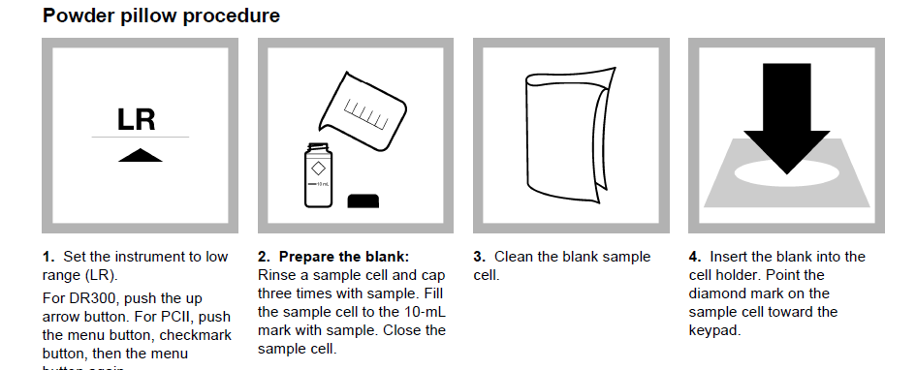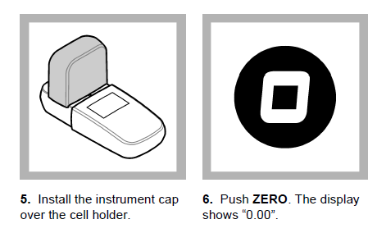
Analysis of the low check standard (for example, 0.02 mg/L) complete this initially and then recheck it each year:
- Pour about 50 mL of standard in a glass beaker
- Pour 10 mL of this standard into the instrument cell (after rinsing with the “standard” 3 times).
- Cut open packet, squeeze open the sides carefully and pour the dry powder into the cell
- Cap the cell and mix thoroughly and start timer
- Wait 3.00 minutes
- Wipe off any smudges from the cell with a soft, lint-free tissue and place in colorimeter
- Make sure instrument cap is closed on the cell holder before pushing read
- Record the concentration displayed on the benchsheet (see attachment A)
- Confirm recovery is within 50-150% of expected result
- Rinse the cell thoroughly with reagent water in between standards
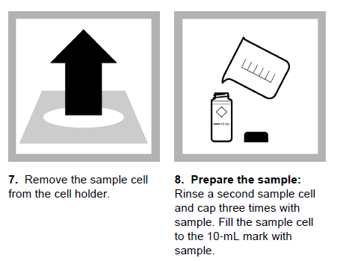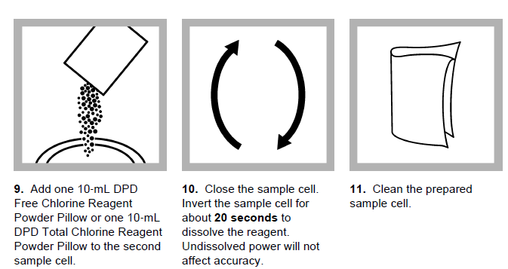
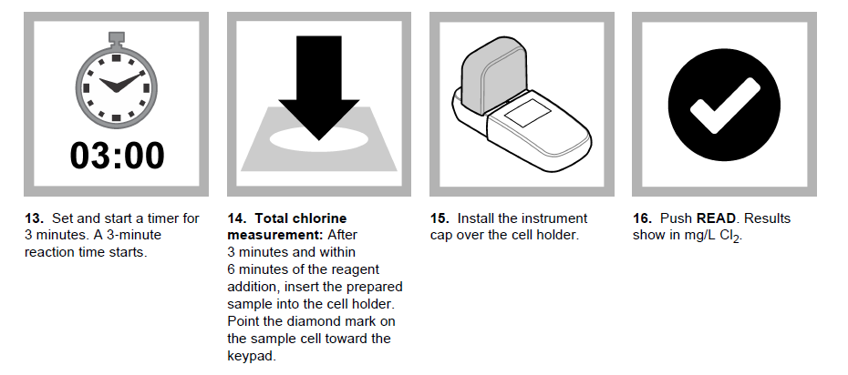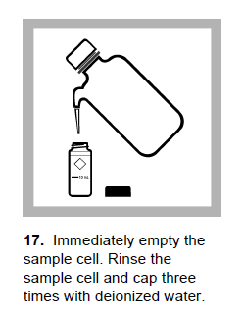

Analysis of the discharge sample (follow the same process as above)
- Warm up the instrument up ahead of time, make sure all supplies are ready.
- Collect the effluent sample in a clean glass bottle and fill it completely to exclude air
- The sample must be tested within 15 minutes of collection
- Rinse the instrument cell three separate times with sample
- Pour about 50 mL of sample in a glass beaker
- Pour 10 mL of this sample into the instrument cell – after rinsing 3x with the sample.
- Close the instrument cap and hit zero
- Cut open packet, squeeze open the sides carefully and pour the dry powder into the cell
- Cap the cell and mix thoroughly and start timer
- Wait 3.00 minutes.
- Wipe off any smudges from the cell with a soft, lint-free tissue and place in colorimeter
- Make sure instrument cap is closed on the cell holder before pushing read
- Record the concentration displayed on the benchsheet
- Rinse the cell thoroughly with reagent water – if DPD reagent remains in the cell it will stain and cause problems.

It is very important to use clean glassware and keep everything clean throughout. As a check on the glassware and the process, the lab should also analyze a method blank.

See the example benchsheet in Attachment A.

For some basic training, consider viewing this video in the link below. Keep in mind this is just an overview and laboratories must still use an approved method and follow any instrumentation and method instructions.

https://www.youtube.com/watch?v=NHUHfiwqNoQ

Attachment A: Total Chlorine benchsheet

Laboratory:____________________________

Facility Permit Limit _________________mg/L | Instrument LOQ that meets 50-150%:_________ mg/L

_____ Sample was analyzed within ~15 minutes of collection and was analyzed after zeroing the colorimeter
_____ Total Chlorine was analyzed (not free chlorine)
_____ The low verification standard was analyzed within the last year (Date completed :_______________)
_____ The low standard verification concentration: ________ mg/L; Percent recovery: _________ %
_____ The low standard concentration is at or below the permit limit (Permit Limit:_______mg/L)
_____ The low standard verification analyzed met the limit of 50-150% recovery.

Analyst
Date of Analysis
Time of Analysis
Sample ID
Sample result mg/L

