Annual verification of the digestion block for TP closed vessels
- If you’re using a digital block, you will want to take a used Hach vial, clean it out really well, and add glycerol or glycerin if you have it. You can also use an oil that doesn’t boil at 150°C. You could even use sand if necessary. You just want something in the tube that won’t boil out and that will help evenly distribute the heat to the thermometer. Put the thermometer into the tube, and put it in the block. Start heating up the block. Once it’s at temp, let the reading on the thermometer stabilize. It may also help to put a loose tent of aluminum foil around the top to kind of act like the cover. If the thermometer reading is not 148 – 152°C, you will need to adjust the block. The user manual has instructions for that.
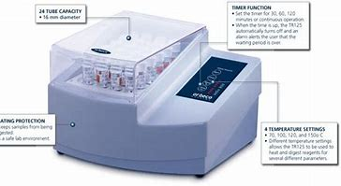

Date:_____________
Initials:___________
Block Temp setting: ______ºC
Thermometer temp:______ ºC

Pass within 2ºC? Yes or NO
If NO, then adjust and recheck it.

