LOD (MDL) Study Instructions
See the spreadsheet for additional notes and instructions

Initial LOD: You will need to do a new LOD if you start doing a new method, you only run a certain test a couple of times per year, or if your ongoing LOD doesn’t pass (see next section). To do the initial LOD:
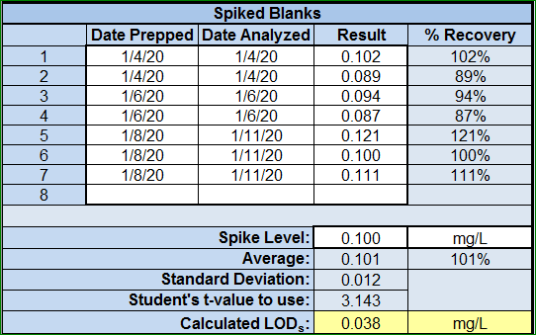
- Prepare 2 or 3 spiked blanks on at least 3 different days so that you have at least seven spiked blanks.
  - For example, you can prepare two 0.1 mg/L total phosphorus solutions on Monday and run the samples on Monday. On Wednesday, you can prepare two 0.1 mg/L total phosphorus solutions and run then on Wednesday. On Friday you can prepare three 0.1 mg/L total phosphorus solutions and run then on Friday. You don’t have to prepare and analyze them the same day, but you do still need at least 3 days of prep and 3 days of analysis.
  - If you happen to have blank spikes at 0.1 mg/L, say from a low-level standard check, you can use that data, but you need to use all of the data.
  - Enter this data in the spreadsheet. Use the tab labeled “Initial LOD.” Enter all dates, results, and the spike concentration in the section labeled, “Spiked Blanks.”
- If any of the spiked blanks give a negative result, you need to start the initial LOD again but at a higher concentration.
- The LOD_{s} is calculated the same way as in the old procedure (the spreadsheet will do the calculations).
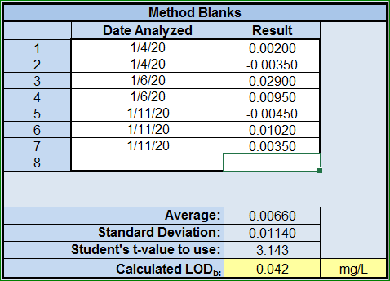
- Compile the most recent method blanks you’ve run to calculate the LOD_{b}.
  - If this is a new method or rarely used method and you don’t have at least 7 method blanks, you will need to analyze a method blank with each of the spiked blanks you ran in step 1.
  - Enter this data in the spreadsheet in the section labeled, “Method Blanks.”
  - Be sure to enter all “-” with any negative values that were measured.
  - The spreadsheet will calculate the LOD_{b} based on the average, standard deviation, and t-value.
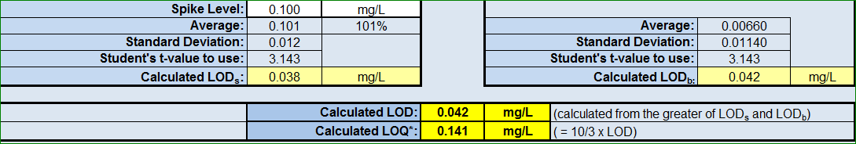
- The LOD will be the higher of the LOD_{s} or LOD_{b} (the spreadsheet will automatically calculate it).

LOD (MDL) Study Instructions (Continued)
Ongoing LOD and Verification: Once you have all of your initial LOD studies done, you will need to start collecting data for the ongoing studies. To do the ongoing LOD and verification:
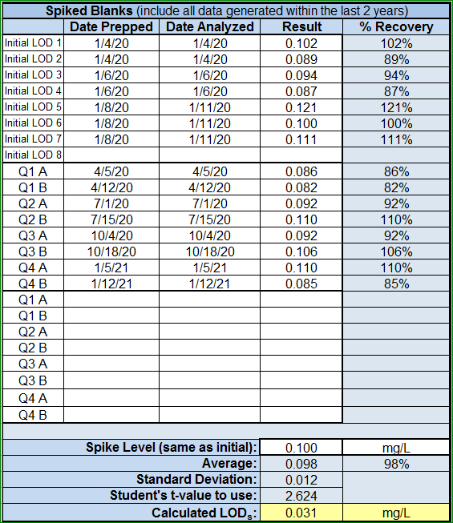
- Each quarter, prepare and run at least 2 spiked blanks using the same concentration as that used for initial LOD. These must be run in different batches each quarter. By the end of twelve months, you will have 8 spiked blanks.
  - If a method is rarely run, you only need to run the 2 spiked blanks in quarters that you run actual samples (PT samples aren’t considered actual samples).
- If more than 5% of the spiked blanks are negative, the initial LOD must be redone at a higher concentration (the spreadsheet will alert you).
- Calculate the LOD_{s} with all data from the last two years, but only data with the same spiking level. This may include the 7 or 8 spiked blanks from the initial LOD if it was done within the last 2 years.
- Enter this data on the “Ongoing LOD” tab of the spreadsheet. Not all of the lines in the Spiked Blanks section need to be filled.
- Compile all method blanks. Ideally, use all method blanks from the last 2 years.
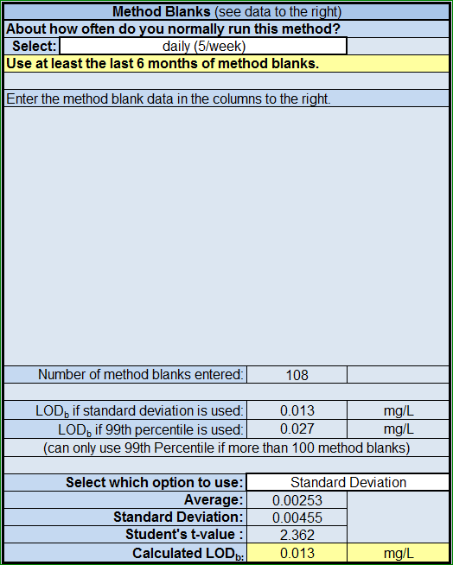
  - If more than 100 method blanks have been run in the last 2 years, you have the option to use either the 99th percentile calculation or the standard deviation calculation. The spreadsheet will show what the results would be from both options (if applicable).
  - You have the option to use only the last 6 months or the 50 last method blanks, whichever yields the greater number of method blanks.
    - The spreadsheet has a spot to enter how frequently a test is run—this will help determine if you need to use the last 6 months, last 50, or last two years of method blanks.
- The spreadsheet will calculate the ongoing LOD.
  - The LOD will be the greater of the LOD_{s} or LOD_{b}.
  - If the LOD is within 0.5 – 2 times the existing LOD and less than 3% of the method blanks are above the existing LOD, then the existing LOD may be left unchanged (the spreadsheet will say if the LOD can be left unchanged).
  - If the LOD does not meet that criteria, then the LOD must be set to the new LOD (the spreadsheet will say if the LOD must be changed).
