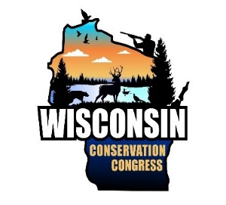

Wisconsin Conservation Congress Photo Release

If the photo subject is under 18 yrs old, this form must be signed by a parent or guardian. Personal information collected will be used for administrative purposes and may be provided to requesters to the extent required by Wisconsin Open Records Laws (19.31-19.39, Wis. Stats.).

Name: Email Address: Street: City: Zip: Phone:

I, , consent to the reproduction and use of my likeness by the State of Wisconsin, Department of Natural Resources (DNR)/ Wisconsin Conservation Congress (WCC) in all manners, including advertising, display, exhibition and art purposes in perpetuity. And I consent to the use of my photograph by any nominee or designee of the State of Wisconsin, Department of Natural Resources/ Wisconsin Conservation Congress including any publisher or agency, and such picture of me may be used for all of the aforesaid purposes without any limitation or reservation.

Signature: , Date:

I, , I grant the Department of Natural Resources/ (Parent/legal guardian printed name)

Wisconsin Conservation Congress and its agent's permission to take, use, and maintain images (photographs, videos, etc.) of my child in connection with my child's visit to a DNR property or participation in a DNR or WCC function for all legitimate purposes, such as advertising and displays. I consent to the photo release for the individual as described above.

Parent/legal guardian signature: , Date: