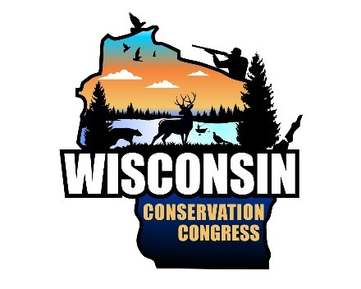

WCC Advisory Committee Evaluation

**Advisory Committee**

|  |
| --- |
| This is your opportunity to provide the leadership of the WCC with your input and feedback regarding your advisory committee meeting. In our ongoing effort to ensure the WCC encourages leadership and involvement at all levels, we want to hear your comments about your advisory committee meeting-good, bad, or otherwise.  For example: Were there issues or topics that you think your committee could have or should have reviewed? If so, let us know what they are. Is there something we could do to help you better prepare for your meeting? Did you feel that your committee had adequate time to discuss the items on your agenda? Did you feel that the meeting was productive? Did the committee function well? (i.e. Did the committee leaders effectively facilitate the meeting and were the committee members engaged and participating in the discussion?) If you have any additional  comments about your committee meeting or ideas that would improve the experience or help your committee be more effective, efficient, or productive, please let us know.  Here is your chance to share your thoughts with us. You are welcome to remain anonymous. |
| **[Enter your comments here]** |

If you are on more than one committee, please fill out a separate sheet for each committee.

Send completed evaluations to the Conservation Congress Liaison at PO Box 7921, Madison, WI 53707 or [DNRWCCLiaison@Wisconsin.gov.](mailto:%20DNRWCCLiaison@Wisconsin.gov)